Mobile SDK
Architecture Description

Date: 01st October 2013
Revision: 0.1
Status: DRAFT

Revision History
Date | Revision | Reason for Change | Author
01st October 2013 | 0.1 | Initial Draft Version | Susan Collins

TABLE OF CONTENTS
1 Purpose of Document 6
2 Overview 6
2.1 Background 6
2.1.1 Developing Mobile Apps 6
2.1.2 Worklight Studio 7
2.1.3 Dojo mobile 7
2.1.4 Worklight Server 8
2.1.5 Worklight Market Place 8
2.2 Cúram Mobile SDK Features 8
2.2.1 Features That Will Not be Developed 9
3 Related Documents and Location 10
4 Cúram Data Service Layer 11
4.1 Background 11
4.2 Architecture Overview 12
4.2.1 Data Service Layer Servlet 12
4.2.2 Configuration 12
4.2.3 URI Format 13
4.2.4 Security 14
4.2.5 Cúram Mobile APIs 14
4.2.6 Data Interchange Format 15
4.2.7 Utility APIs 17
4.3 Non Functional Requirements 17
4.3.1 Performance 17
4.3.2 Customization 18
4.3.3 Internal Development Support 18
4.3.4 Upgradeability 18
4.3.5 Testability 18
4.3.6 Usability 18
4.3.7 Accessibility 18
4.3.8 Internationalization 18
4.3.9 Security 18
5 Mobile Centre of Competency Integration 19
5.1 Overview 19
5.2 Non Functional Requirements 19
5.2.1 Performance 19
5.2.2 Customization 20
5.2.3 Upgradeability 20
6 IBM Worklight Integration 21
6.1 Overview 21
6.2 Worklight Studio 21
6.2.1 Ideal Development Environment 21
6.2.2 Simulation and Testing Environment 22
6.2.3 Development Process Overview 22
6.3 Worklight Server 23
6.3.1 Cúram Adapter 23
6.3.2 WebSphere/Worklight Integration Support 24
6.4 Worklight Topolgy & Security 25
6.5 Third Party Dependencies 25
6.6 Weblogic Support 26
6.7 Non Functional Requirements 27
6.7.1 Performance 27
6.7.2 Upgradeability 27
6.7.3 Usability 27
7 Mobile SDK Delivery 28
7.1 Overview 28
7.2 Licensing 28
7.3 Worklight Packaging 28
8 Internal Development of Mobile Apps 30
8.1 Overview 30
8.2 Remit of the Sample Application 30
8.3 Sample Application Non-functional Requirements 31
9 Offline Support 33
9.1 Overview 33
9.2 Read Cache 33
9.3 Request Queuing 35
9.4 Worklight Caching Support 35
9.5 Non Functional Requirements 36
9.5.1 Performance 36
9.5.2 Security & Regulation 36
10 Pagination 37
10.1 Overview 37
10.2 Pagination in Cúram Data Service Layer 37
10.3 Non Functional Requirements 38
10.3.1 Performance 38
11 Appendix 1 – Documentation 39
12 Appendix 2 - Glossary 40
13 Appendix 3 – Project Stakeholders 41
14 Appendix 4 - Decisions and Alternatives 42
14.1 Two Mobile Development Approaches 42
14.2 Mobile UIM 42
14.2.1 Introduction 42
14.2.2 UIM Gap Analysis 43
14.2.3 UIM Infrastructure 44
14.2.4 Approach 1: The JavaScript Shell App 44
14.2.5 Approach 2: HTML Generated App 46
14.2.6 Development Environment 47
14.3 Mobile Access Point 48
14.3.1 Introduction 48
14.3.2 Access Point Infrastructure 48
14.3.3 Access Point Options 49
14.3.4 Servlet 50
14.3.5 UIM Data Provider 51
14.3.6 Web Service 51
14.3.7 Data Contract 52
14.3.8 Infrastructure Services 53
14.3.9 Pagination Support 54
14.3.10 Error Handling 54
14.3.11 Packaging of the Access Point 55

Purpose of Document
The purpose of this document is to provide an Architecture Description for the Mobile SDK. The aim of the Cúram Mobile SDK is to provide a set of tools to our customers and business partners that will enable them to develop Cúram mobile applications.
- Overview
  - Background
Over the past few years, since the iPhone became popular, Smartphone and mobile applications (“apps”) have become mainstream. This has led to an interest in “Cúram for Mobile”, both in Product Development and among customers.
During v6 timelines a Cúram mobile application was developed for the CCS project. It is a native iPhone application and was developed by an external company specializing in iPhone app development. It was very well received at user conferences in 2011. However, outsourcing mobile app development in this way is not a sustainable solution, and does not help our customers create similar apps.
A large focus for IBM at present is Mobile support, including a Mobile First Agenda and a Mobile stack offering. Industry Solutions is now embracing IBM's Mobile First Agenda and according to this directive, solutions will be developed with Mobile in mind from their earliest stages of design.
Developing with mobile first in mind, is not suitable for the full Cúram application due to the existing client infrastructure and 20,000 product pages already in existence. The mobile strategy within Cúram is instead being considered under a number of different banners:
- Mobile SDK
A mobile development kit that will empower our customers and business partners to create mobile Apps for specific social use cases.
- Tablet Support
Support for the existing Cúram web application running on tablet-sized devices.
- SMS Support
Support for interaction with Cúram via SMS messages.
This architecture document is concerned with the Mobile SDK only.
    - Developing Mobile Apps
There are a number of approaches available to a developer when developing mobile apps, including:
- Native Development
Native development involves producing mobile applications using mobile vendor (Apple, Android, etc.) specific APIs. For example, using X-Code with Apple.
Such mobile apps would have a native feel and it would be possible to optimize them completely. A developer would have unrestricted access to all native hardware capabilities such as camera, geo-location, contacts etc.
- Hybrid Development
A hybrid mobile app is built using HTML 5 CCS 3 and JavaScript. This is then built and packaged as a native app and has access to all the device native capabilities using a third party library such as Cordova/Dojo mobile.
Enabling development of Cúram mobile applications via hybrid development is the preferred approach. This approach allows customers to develop their app for multiple platforms/devices with one common codebase, and IBM Worklight Studio supports development of hybrid apps.
    - Worklight Studio
Worklight Studio enables the development of hybrid and native mobile applications on iOS, Android, BlackBerry, Windows 8 and Windows Phone tablets and smartphones. For hybrid applications, developed using HTML5 and JavaScript, developers can implement the majority of the mobile app in a platform agnostic way.
Worklight Studio provides an Eclipse based IDE and toolset that allows you to build cross platform - HTML 5 based mobile apps with a native wrapper around them. The toolset provides development access to native phone features via the Cordova JavaScript library.
In addition Worklight supports:
- a simulation environment for quickly testing mobile applications in a browser;
- a common web codebase to facilitate reuse and ability to easily override the common code to support different platforms;
- extensive libraries and client APIs that expose and interface with native device functionality and the Worklight server, e.g. Encrypted Storage and Offline Authentication.
This approach is less flexible than pure native development, however it allows for the creation of a consistent mobile application across multiple mobile platforms without duplication.
    - Dojo mobile
Worklight Studio supports the use of a Dojo Mobile JavaScript API. Dojo Mobile is a Dojo-based widget set for creating mobile web applications. With Dojo Mobile, you can develop lightweight, high-performance mobile web applications.
    - Worklight Server
Worklight Server is an Enterprise application which supports mobile applications in production. It includes:
- Worklight Server: A mobile middleware offering unified push notifications, version management, security and integration;
- Worklight Console: A web-based console for real-time analytics and control of your mobile apps and infrastructure;
- Worklight Application Center: The Application Center provides all the mechanics, and operates as simply as the official app stores do. With it there's no need to worry about submission to public app stores, nor worry about your internal apps being available externally;
- Integration with IBM Cast Iron via an out of the box adapter;
- Cross-Platform Compatibility Layer;
- Server Integration Framework;
- Statistics and Diagnostics Reporting;
- Security Integration;
- Device Provisioning.
    - Worklight Market Place
In addition to Worklight Studio and Worklight Server, a Worklight, or IBM Mobile First, Marketplace is currently in development. The marketplace allows for additional content to be installed into a Worklight project. This content can be a component providing additional utilities/building blocks or a template providing a sample of how something can be implemented.
The Worklight marketplace provides potentially the ideal delivery mechanism for Cúram specific utilities to aid customers in the development of mobile applications.
  - Cúram Mobile SDK Features
The Cúram Mobile SDK will include the following features:
- Cúram Data Service Layer: A CDEJ web-tier servlet enabling invocation of Cúram facades from JavaScript Ajax calls. The CSDL will also include JavaScript APIs to support invoking the servlet and handling data formatting and error scenarios.
- Mobile Centre of Competency (MCoC) Core Framework: A set of core JavaScript services that are commonly required by mobile applications, and will be supported as part of the offering.
- Integration with IBM Worklight: The mobile IDE that will be used to aid development and testing of mobile applications for cross platform solutions.
- Offline Support: Basic support for implementing offline scenarios. This will leverage Worklight’s JSONStore, for encrypted storage of content in mobile applications.
- Pagination: Basic support for mobile specific pagination scenarios that enable reduction of data sent to the mobile application.
- Authentication: Support for both integrated authentication with Worklight and basic form based authentication.
    - Features That Will Not be Developed
To avoid any misunderstandings, the following are features that will not be implemented:
- Support for existing Cúram running on a mobile/tablet device;
Note: This is currently being progressed via a separate project.
- Support for feature phones, including SMS support;
Note: Worklight supports SMS messages, where a third party SMS gateway can be configured to handle sending the messages. However, there is no plan to leverage this in the product as part of the mobile SDK.
- User Interface Library.
Dojo Mobile provides a library of widgets tailored for mobile applications.
- Related Documents and Location
Description | Link
Link to Project Stakeholder List | https://w3-connections.ibm.com/wikis/home?lang=en-us#!/wiki/W0a1fd4167cf0_4b87_9de1_934ee047dc09/page/Mobile%20SDK
High Level Requirements | https://w3-connections.ibm.com/communities/service/html/communityview?communityUuid=936e1f65-7f87-4320-8935-59782940d7dd#fullpageWidgetId=Wa15565f62251_4294_aafb_7b6de1afa735&file=035f8a87-1c60-42d9-9431-55d1087efec7
Architecture Description Plan | https://w3-connections.ibm.com/communities/service/html/communityview?communityUuid=63d7b9dc-f07a-42a9-bbe5-ce20a04bee2c#fullpageWidgetId=W91ec6a3e323d_4c43_9731_fb18a83f36c5&file=29b1521e-4cb6-4223-9c88-ab59cc59001b

- Cúram Data Service Layer
  - Background
Providing access from a mobile application to Cúram is one of the main components of the Cúram Mobile SDK. In the early stages of the design a number of options were considered including:
- Support for Mobile UIM: Mobile UIM support would allow customers to develop using the existing UIM infrastructure, and have the mobile apps automatically generated by the Cúram JDE;
- Support for Mobile Access Point: A Mobile Access Point would allow customers to expose a set of server interfaces/facades to be used by a mobile app, leaving the development of the mobile app to the customer.
The Mobile Access Point solution, now called the Cúram Data Service Layer, was chosen as this solution allows us to leverage the full power of the Worklight Product stack and enables Cúram to get to market quickly with a mobile development strategy and solution. It should be noted however that by implementing this solution we are not preventing a future mobile UIM development direction.
A short summary of the advantages and disadvantages of both approach can be seen in the table below, with more details in Appendix 1 – Decisions and Alternatives.
Mobile UIM
Pros | Cons
Quick and easy development of mobile applications | Significant Investment for Cúram
Similar skillset for existing customer developers | Potentially restrictive feature set
Insulate customers from non-functional concerns relating to mobile application development

Mobile Access Point (Cúram Data Service Layer)
Pros | Cons
Implementation flexibility for customers | New skills required by customer developers
Less investment for Cúram | Mobile app development more complex than traditional UIM development
Ready for Market earlier
Fits IBM Mobile first Strategy

Architecture Overview
The Cúram Data Service Layer (CDSL) is a new service that supports invoking Cúram facades via JavaScript AJAX requests. The CDSL comprises of a servlet to handle the requests and a set of JavaScript APIs that can be used by a developer to invoke a façade.
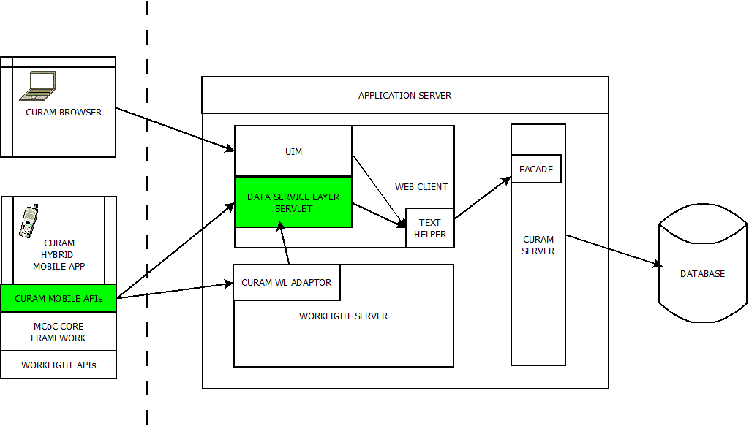
The above diagram outlines how Cúram mobile applications will fit into the existing Cúram architecture. The Cúram Data Service Layer represents the highlighted items in the diagram, specifically:
- Data Service Layer Servlet: A web servlet which handles all requests to invoke Cúram facades.
- Cúram Mobile APIs: A set of JavaScript APIs to aid a developer in invoking Cúram facades.
    - Data Service Layer Servlet
The data service layer servlet is responsible for handling the JavaScript AJAX requests to invoke specific Cúram server interfaces. The servlet will send and receive data in the JSON format and is responsible for parsing and validating this data.
    - Configuration
By default, this API should not expose all Cúram facades, and a configuration file will support a “white list” of facades that can be invoked.
The “white list” configuration file will abstract the service name from the actual façade invoked and allow for further configuration information about the service to be defined.
Note: Including this information in the façade definition in the Cúram model was considered as an approach and rejected in favour of an XML configuration file. This decision was based on the ability to do some configuration of the white list at runtime.
The XML configuration file will allow the mapping of a single façade to a service name. All methods on this façade will then be available as part of the service exposed. It is possible to provide a lower level of granularity, allowing specific methods to be hidden and not exposed, however this was decided against. There is no plan to expose existing Cúram facades via this servlet, which means that all facades exposed should be implemented specifically for invocation from a JavaScript request. The main driving factor behind this is that our existing APIs are not optimised for use in a mobile application. In addition, providing a level of granularity in the service definition introduces a complexity in how this file is handled at a component level, i.e. overriding/merging the contents across components.
Existing service definition languages, including WSDL and WADL, have been considered in defining the content of the configuration file. WSDL is an XML-based interface description language that is used for describing the functionality offered by a web service. (http://en.wikipedia.org/wiki/Web_Services_Description_Language). WADL is a machine-readable XML description of HTTP-based web applications (typically REST web services).
WADL describes services in terms of methods (GET, PUT, etc) detailing the request and response expected. WSDL describes services in terms of interface and operation, and includes schemas for the input and output structures applicable to the exposed service.
Both definitions are very comprehensive and overkill for what we require. A more simple XML configuration along the lines of the following will be used:
</service name=”ABC123” façade=”Person”>
Note: Exposed facades must be unique in name and as a result the fully qualified name of the façade is not required.
At development time, components can add to the configuration file but not overwrite existing services. For example, a component cannot overwrite the implementation of another service by changing the name of the façade or change any additional configuration options.
At runtime, administration screens will be provided to allow control over the services enabled.
Finally, codeline will be defined for this new configuration file. Developers will be allowed add new services, or change an existing service to use a new facade as long as it does not change the existing methods and parameters of the service. The ability to change the configuration options on a service will depend on the final set of configuration options.
    - URI Format
The format of the URI for the data service layer servlet will be something similar to:
<service-root>/<service-name>/<method>
where
- <service-root> is the same for all requests, and it is this part of the URI that ensures the request goes to the data service layer
- <service-name> maps to a specific façade, via the configuration file
- <method> maps to a specific method of the façade
For example:
POST <host>/Curam/data-service/ABC123/modifyAlternativeName
All requests to the servlet will be POST requests and the POST payload will contain a JSON structure representing the required data. This allows complex structs, required by facades, to be mirrored in JSON and sent to the server.
    - Security
Façade invocation from UIMs currently has a two steps authorization process. The web-tier checks to see if the user has rights to invoke the façade and only executes it if they do. In addition, the server-tier checks that the user has access rights to invoke the façade before proceeding.
The servlet will implement a (or leverage the existing) security check to ensure the user has access before attempting to invoke façade, to continue to provide this two step process.
In addition to function security, the servlet will provide support for field level security and data sanitization, e.g. XSS/XRCF support. The IBM Active Content Filter will be used by default for all data, with a configuration option on the service definition (disable-filter-content) to disable this feature.
Note: The use of the IBM Active Content Filter can be turned off per façade only.
AppScan supports running on a mobile application .. will be run on both the sample and the full code
    - Cúram Mobile APIs
The JavaScript APIs will comprise of a direct Request API for invoking the Cúram facades and a Cúram Store.
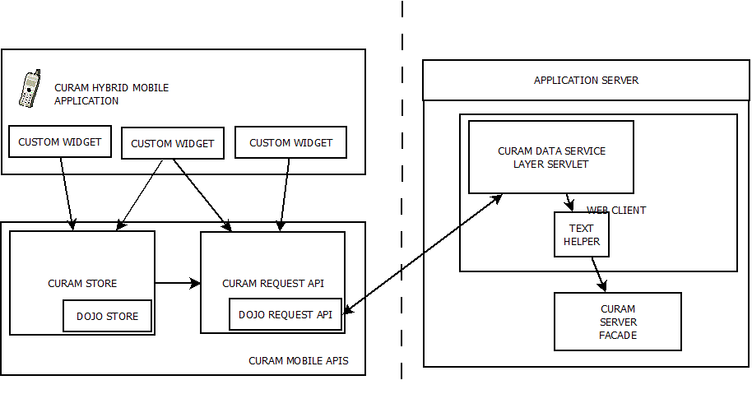
The Cúram Request API will extend the existing Dojo Request API and allow the direct invocation of the data service layer servlet. The request API will be responsible for error handling, session timeout and network connectivity problems and parsing/handling of data formats. In addition, it will include necessary hook-points to allow overwriting of any default error handling, etc.
The Cúram Store will be an implementation of a Dojo Store and will provide a standard Dojo layer for performing CRUD operations. A Dojo Store is a uniform interface for the access and manipulation of stored data, and is intended to abstract data consumers (e.g. widgets) from the concerns of the data provider (e.g. the façade). Dojo widgets will be used to build up the mobile app interface, and the Cúram Store will implement a standard dojo pattern for feeding widgets with data.
Dojo Stores are based around PUT, GET, DELETE, etc operations. These will be mapped, by convention, to specific façade methods. For example, the GET method will map to a read method on the façade and the DELETE method to the remove method. Support for overwriting the mappings will be provided via configuration options of the store.
Facades implemented for use with a Cúram store are intended to be CRUD style facades and should follow a defined pattern and best practice standards.
    - Data Interchange Format
The choice of data interchange format used to represent Cúram structs is JSON. The main reasons for this include:
- In web development, JSON is established as one of the main data-interchange formats (XML being the main rival).
- The CDSL is a JavaScript library and JSON notation is also valid JavaScript notation. It is far more efficient to convert JSON into a native JavaScript object than say a piece of XML.
- JSON maps well to the inputs and outputs of Cúram facade operations (this will be explored in detail in this document).
- Any of the technologies used at the browser tier of web application development have string JSON support. For example:
  - The widgets in the Dojo library use JSON as their preferred data format
  - Other libraries and frameworks such as jQuery, Angular and Dart all have good JSON support. So, the CDSL will be flexible and potentially open to use in client application's other than Cúram's.
"Structs" in the Cúram model result in generated Java classes when the server is built. The JSON data format can represent simple data structures and maps, with support for arrays and aggregation (aggregation "by value", not "by reference"). This maps nicely to generated Cúram "structs".
Further design is require around:
- Data Types: For each Java data type we need to define the JSON representation. This needs to consider both the "raw" and String representations.
- Metadata: Converting a struct to JSON loses information such as attribute type and the struct class declaration. How do we simulate this meta data in the JSON representation? What format does the metadata take?
- Aggregations: Aggregations was only briefly mentioned above and not covered in the simple struct example. More complex 1-to-1 and 1-to-many aggregations have to be explored.
Apart from a Cúram specific data structure like a code table, the native JSON representations for Cúram's "base" types are pretty self explanatory.
For the scope of the first release of the CDSL, the users of this API will be feeding the data into widgets (e.g. Dojo text input, Dojo charts etc.) which actually expect the native representation and in turn will handle the client side formatting. As a result, by default, only the "native" representations will be provided in the JSON-to-struct mapping.
A configuration option on the Cúram request API/Cúram store will be supported to return the web-tier formatted value, in addition to the raw format.
There is an important side-effect of this decision which must be noted. The Cúram infrastructure formats data by default based on the base type. However, it also allows this to be customized. For example, a developer can create a new domain definition and associate their own converter class with it. This converter is responsible for both parsing and formatting the string representation of that type. So, for example, the number "123456" could be formatted as "1-23-345". By using only native values, the CDSL will not support this formatting. It will be up to the user of the API to replicate this formatting or parsing if necessary.
    - Utility APIs
The Cúram CDEJ client infrastructure abstracts a lot of infrastructure from developers, including details of the raw versus formatted values. To aid customers when manually developing mobile applications a number of additional infrastructure services will be developed. The following is the list of suggested services.
Note: These are based on the existing infrastructure support, but all may not be required by mobile apps.
- Code Table Support
API to retrieve the full definition for a particular code table and functions to translate code values to the descriptions.
Note: Code table security is currently implicit based on the façade accessed. This will continue to be the case the API will be restricted in the code tables that can be accessed.
- Domain Support
API to retrieve Domain information.
- Field Level Security
A service to determine if a particular field is secured, based on the user.
- User preferences Access
API to access a specific user preferences and the list of all user preferences.
- Global Cúram Configuration Access
API to access to both the client configuration settings and the full application properties (.prx). Client configuration settings include Date/Time settings, address formats, default locale, etc. Not all of these would be applicable to a mobile and only those necessary should be exposed.
- Binary Data Access
API to support accessing binary data, such as images, from the server. This API needs to consider, at a minimum, both accessing images from the Resource Store and general access to tables that are using the SVR_BLOB domain.
  - Non Functional Requirements
    - Performance
There are two areas where performance is a concern; the data service layer servlet and the JavaScript APIs. The CSDL servlet is like most of the other servlets supported in the web-tier and should pose no performance concerns. However, P&S will be engaged as early as possible in the project to profile the servlet and ensure no concerns.
There are performance problems with JavaScript on some browsers (Internet Explorer 8) at present and any JavaScript APIs we provide must perform. Any JavaScript APIs we produce need to be tested, and built, with performance in mind, especially given performance on a mobile device is key. A sample mobile application will be used to test performance across a range of supported devices.
However, it is worth noting that performance testing on mobile devices is a new area and will require up-skilling to understand how best to do this.
    - Customization
The Cúram Data Service Layer servlet is customizable via a configuration file and how this file will be customized by customers has been considered.
The JavaScript APIs will provide a level of customization hook-points, allowing developers to replace default behaviour where relevant, e.g. error handling, session timeout, etc. This API will be clearly documented and is essentially a black-box, outside of clearly documented hook-points.
    - Internal Development Support
The Cúram Data Service Layer will be used internally by teams, initially for development of …..
    - Upgradeability
    - Testability
    - Usability
    - Accessibility
    - Internationalization
    - Security
Login from multiple devices – how to handle? Is necessary? Logging?

- Mobile Centre of Competency Integration
  - Overview
Industry Solutions Mobile Centre of Competency (MCoC) are developing a number of components to aid in the development of mobile applications. The Core Framework Component provides an MVC framework out of the box, which is easily extendable with custom Views, Controllers and Models, and provides a best practice base from which to develop mobile applications.
This core framework is the ideal base for the Cúram sample application. It is an extension of the Dojo app functionality, and provides a standard way of structuring mobile applications. By relying on it we are also leveraging the mobile experience of the MCoC team.
The MCoC core framework is a relatively new and immature delivery. It has been used internally by other Industry Solutions teams, but is not publically available. In relying on this framework we are choosing to be bleeding edge in technology adoption, and there is a large risk associated with this. However, given the benefit of both the delivery mechanism for our framework and the best practice benefits that the MCoC core framework give us, we believe this risk is worth it. The alternative is for us to develop this functionality on our own, which we do not have the expertise to do so, and is a more risky proposition.
To mitigate the integration risk, the proposal is to incorporate the MCoC content as part of the Cúram deliverable. This removes the risk of their content not being available publically in our timelines.
In addition, this approach allows us to control when a new version of the content is supported, similar to third party libraries such as dojo, and handle any bug fixes that may be required. The MCoC are a small team and are more likely to resolve issues on the latest version of the framework and this approach may not suit the timelines and nature of fixes Cúram provides to is customers. By including their content, instead of a dependency on it, we can work with the MCoC to support fixes on specific versions as necessary.
The MCoC documentation is currently internal Wiki documentation only, given they are not a public delivery. In taking this approach, we will be responsible for documenting the parts of the framework a customer is supported in using, and thus can control the surface area of what is exposed based on our own testing and usage.
  - Non Functional Requirements
    - Performance
The MCoC core framework will be performance tested as part of its integration with the sample application. See the section relating to Internal Development of Mobile Apps for more information.
    - Customization
Customers will not be allowed customize any content from MCoC and will be restricted to only the APIs documented and supported.
    - Upgradeability
Cúram does not have control over the changes made to the MCoC core framework and cannot prevent upgrade impacts. As with tools such as dojo and Worklight, impacts are a high probability for customers as they upgrade version and tooling.
Our own experience with dojo upgrades has proved problematic and customers are taking this risk and effort when they start developing hybrid based mobile applications.
We will mitigate this risk in relation to the MCoC core framework by controlling the surface area of what we expose. If there is any impact in a future upgrade, we will then have to document clearly for the customer the changes. MCoC are aware of preventing impact and work towards this goal.
It is worth noting that Mobile applications are seen as a different development approach to the traditional Cúram development cycle. Apps are developed and re-developed in short time cycles and in a fast moving environment. The implications of upgrades and impact will be clearly outlined in customer documentation, to set expectations around support for customer mobile apps.
- IBM Worklight Integration
  - Overview
IBM Worklight Studio and Server form the base of the product stack for supporting development and deployment of mobile applications.
Worklight Studio enables the development of hybrid and native mobile applications via an Eclipse based IDE and toolset that allows you to build cross platform, HTML 5 based, mobile apps with a native wrapper around them.
Worklight Server is an Enterprise application which supports mobile applications in production.
In addition to Worklight Studio and Worklight Server, a Worklight marketplace is currently in development. The marketplace aims to provide a mechanism for delivering additional content to aid in developing mobile applications within Worklight.
  - Worklight Studio
Worklight Studio will be used as the IDE for customers to develop Cúram mobile applications. Developers will be provided with Worklight content, in the form of a Worklight marketplace template, which provides both a starting point and guidance for developing mobile applications. See Mobile SDK Delivery section for more details on packaging of content.
    - Ideal Development Environment
The ideal development environment for a mobile developer, using Worklight studio, is a single integrated Eclipse environment. In this environment they will have access to:
- Worklight studio plug-ins for developing and testing mobile application
- Rational modelling environment for developing Cúram facades
- Cúram EJBServer, webclient and other projects for running a Cúram server
This environment assumes that the mobile application developer is the same as the Cúram developer. Given the additional skills required for mobile development, this assumption may not be valid.
In addition, this ideal integrated environment does not currently perform. Eclipse cannot handle the number of projects and plug-ins that are installed in this scenario.
While we will investigate further if any performance improvements can be gained by Eclipse configuration settings, it is unlikely that we will support a single eclipse environment. Instead, mobile applications should be developed in the standalone Worklight studio. Cúram can be run either in another Eclipse instance locally, or alternatively deployed with the facades already developed on a build server.
    - Simulation and Testing Environment
A key feature of Worklight studio is the simulation environment it provides for testing mobile applications. The Worklight simulation environment provides approximately 60% accuracy in the look & feel and functionality of the application, however it has some limitations.
The simulation environment is a browser based testing environment, which relies on Chrome or Safari and the fact that they using the WebKit browser engine. The WebKit browser engine is the basis for the display of HTML/JavaScript content on most mobile platforms, including Android and iOS. Unfortunately Chrome has recently announced a move away from the open source WebKit and it is unclear at this time what this fully means for simulation of mobile environments using Chrome. As Chrome deviates further away from WebKit it will eventually become unreliable in simulating a mobile device using WebKit.
Using the Worklight simulation environment encounters two issues with the default Cúram deployments:
- Unsigned certificates: By default Cúram WebSphere configuration uses the OOTB certificate, which is not fully valid. This certificate causes a browser warning page to be displayed (and accepted) in normal usage. When testing connection from a mobile application, this certificate cannot be handled.
The workaround is to access the Cúram server and accept the certificate before running the simulation environment.
- Cross Site Request Forgery: In a mobile application, the browser engine does not check for standard CSRF issues. This is because it is expected that a mobile app, which is self contained, will access another server for information. However, as the simulation environment is running in a normal browser this check is performed and prevents the mobile app from invoking the Cúram server.
There are two workarounds for this, the first of which is to disable the security settings in Chrome. The second is to set a header option on every response from the Cúram server to prevent this. This second option will be implemented for development environments only, or optionally turned on as necessary.
The Worklight simulation environment only provides an initial test bed for mobile apps. The next step is to test using the device specific emulator and finally on the supported devices using built binary files.
    - Development Process Overview
The following steps outline the steps required to develop, build and deploy a mobile application using Worklight.
- Setup development environment
  - Install Worklight Studio
  - Install Cúram sample application template
    - Will include Cúram mobile APIs and MCoC core framework
  - Update configuration files to connect to a Cúram server
  - Test and verify sample application
- Develop Cúram facades
  - Design and model mobile specific facades
  - Implement business logic, re-using existing functionality where possible
  - Enable the facades for use in the Cúram Data Service Layer (CDSL)
- Develop mobile UI collateral
  - Develop HTML and JavaScript content for the mobile app
    - Using dojo widgets and the MCoC core framework for structuring the app
  - Invoke the Cúram facades using the Cúram mobile APIs
  - Test the application using the Worklight simulation environment
  - Test the application using the device specific emulator
- Integrate Worklight and WebSphere
  - Install and configure Worklight consumer edition
  - Package the Worklight studio project as a WAR and deploy to Worklight server
- Device testing
  - Within Worklight studio, build the binary file for the support environments, e.g. ipa for iOS and .apk for Android.
  - Deploy directly to device for testing.
  - Worklight Server
    - Cúram Adapter
The main integration point with Worklight server is the ability to use a Worklight adapter to connect to the Cúram Data Service Layer.
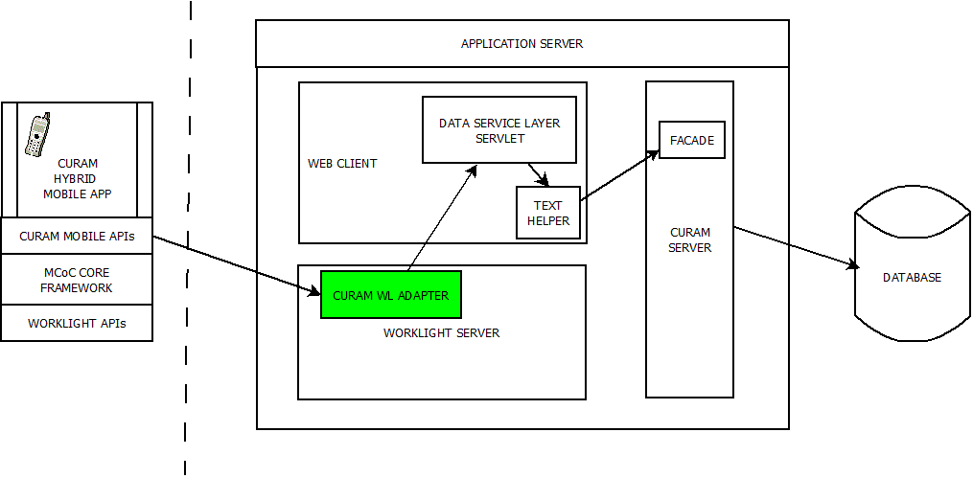
Worklight adapters are the server-side code of applications that are deployed on and serviced by Worklight. Adapters connect to enterprise applications (otherwise referred to as back-end systems), deliver data to and from mobile applications, and perform any necessary server-side logic on this data.
Worklight adapters use flexible authentication facilities to create connections with back-end systems. In addition, adapters offer control over the identity of the user with whom the connection is made. The user can be a system user, or a user on whose behalf the transaction is made.
For Cúram the main advantage of using an adapter is providing customers with the ability to leverage the enterprise features of Worklight, e.g. security integration, analytics, device provision, etc. The Cúram adapter will be a very simple “routing” HTML adapter, that takes the original request and forwards it to the configured Cúram server and returns the provided JSON response.
An adapter in Worklight is basically an XML configuration file, which specifies the server and port to connect to and a JavaScript file that performs the logic of the request. The Cúram adapter will be delivered as part of the Worklight sample application and does not form part of the Cúram mobile APIs. The main reason for this is the configurable nature of the adapter and it also allows the flexibility to the customers to include additional logic within the adapter.
    - WebSphere/Worklight Integration Support
One potential deployment topology for customers is the deployment of Worklight on the same WebSphere cluster supporting Cúram. The main advantage of this approach is the integrated security configuration that is possible.
Where Worklight is installed on WebSphere, it can leverage the security configuration of WebSphere. Initial prototyping of this configuration was performed as part of playback zero and proved that a high level this was possible, but with some limitations.
As part of this work, Worklight was installed onto a pre-configured Cúram WebSphere instance and the Worklight Security tutorial used as a proof of concept. The two main limitations encountered were the implementation of the authentication screens using the Worklight APIs and the lack of identity propagation from the Worklight adapter.
The Worklight APIs essentially identify when a response from the Worklight server is a login screen and allow the developer to handle this and display the login screen. The login screen then uses JavaScript to submit to the j_security_check action. The APIs wrap this process to some extent, but not in a very complicated fashion.
In addition, the Worklight adapter does not automatically include the WebSphere LTAP2 token when sending the request to the Cúram server. You must retrieve the cookie in JavaScript within the adapter and manually include it in all subsequent requests.
This approach is no more efficient than writing JavaScript to directly check for the login page and submit to j_security_check action. However, Worklight does provide additional security mechanism, relating to device provisioning and protection, that go hand-in-hand with this approach and a customer may wish to leverage.
Integration steps for packaging up Worklight for deployment on a Cúram WebSphere instance will be provided as part of documentation. In addition, this new topology will be refined with the PE-SVT group to ensure it meets a recommended approach for customers. For example, the topology needs to consider how the Worklight server will be configured in conjunction with a web server, than often sits outside of a DMZ to allow external/public access to the system.
  - Worklight Topolgy & Security
The IBM redbook Securing your Mobile Business with IBM Worklight, describes a typical Worklight platform setup as follows:
“.. the Worklight Server is installed behind a firewall or Web reverse proxy such as Security Access Manager or WebSphere DataPower, and the mobile applications are installed and run on mobile devices, which at least partly reside outside the enterprise network. The Worklight Server acts as a gateway mediating the communication and access of mobile applications to back-end systems and can be further secured using Security Access Manager or WebSphere DataPower.”
It is beyond the scope of this project to verify and test integration with Security Access Manager and WebSphere DataPower, however a basic Worklight/WebSphere topology will be tested in conjunction with the PE-SVT group. The details of this topology are yet to be fully defined.
  - Third Party Dependencies
Cúram supports the following versions of software:
- Eclipse 3.6.2
- Rational Software Architect 8
- Tomcat 6.0
- Java 6
- WebSphere 7, 8 and 8.5
Worklight supports the following versions of software:
- Eclipse 4.2.2
- Rational Software Architect 9.0
- IBM Installation Manager 1.6.3
- Java 6 & 7
- WebSphere 7, 8, 8.5 and 8.5.5
- TomCat 7
In an ideal world, this means we must upgrade Tomcat, Eclipse and Rational Software Architect versions to be in-line with Worklight support. However, as detailed above we are planning on running Worklight Studio in a standalone Eclipse environment due to performance reasons. This means that we are not required to bring the Cúram software prerequisites in line with Worklight. Should this situation change, we will have to revisit this decision.
  - Weblogic Support
Worklight Server runs on both the WebSphere and Tomcat application servers, however it does not support the WebLogic application server. This particular issue has been a large concern throughout the initial stages of mobile SDK project and details on the history of this can be found here.
This issue was a fundamental catch-22 situation, where by supporting Worklight we were fitting in with the IBM mobile first strategy, but ignoring our WebLogic customers. Equally, the reverse situation prevented us leveraging the support behind the mobile first strategy and went against IBM direction.
Our eventual proposal was to support a sample application built and relying on Worklight, but also support the Cúram Data Service Layer from outside of Worklight. WebLogic customers would not get the same level of collateral, but would be able to create mobile applications using Cúram data.
The conclusion, based on feedback from playback zero, was that this approach was not necessary and we are to support blue stack only. However, we should not do anything architecturally that would prevent us from supporting the Cúram Data Service Layer on its own in the future.
  - Non Functional Requirements
    - Performance
The performance of the development environment will be investigated further to determine if Cúram and Worklight can be run within the same Eclipse environment, however this is unlikely.
Performance of the Worklight adapter will be investigated over the course of the project, however any concerns here are likely to be Worklight given the simple nature of the Cúram adapter. If encountered, the Worklight team will be engaged to resolve these.
    - Upgradeability
This is a unknown quantity. We are adopting a new third party tool and have to build up experience of what support they provide and how well they prevent impacts during upgrades. Initial work with Worklight and moving from version 5 to version 6 resulted in impact on the most basic of projects. This would leave a low level of confidence in this going forward, but a hope that they will improve with each release.
    - Usability
Usability of the development environment is an accepted risk for the project. Worklight Studio provides a HTML/JavaScript based development environment with a less than basic drag and drop interface. As a developer, the drag and drop interface provides the template HTML required to use a particular widget, but a developer will still manually modify this content to complete their application. Worklight provides a preview of the HTML content, but from minimal experience this has a tendency not to accurately represent what will be displayed on the device.
Apple and the iOS development experience is a very clean and easy drag & drop development environment. Developers used to this environment will find Worklight Studio lacking.
The mitigation for this is the understanding that Worklight is a hybrid development environment and not a native development environment. It is intended for JavaScript/HTML developers who are used to writing this manually. In addition, the Worklight marketplace offers a source of re-usable components and building blocks that over time will make development of hybrid mobile applications easier and quicker.
- Mobile SDK Delivery
  - Overview
There are a number of parts to the packaging of the Cúram Mobile SDK, specifically:
- The Cúram Sample Mobile Application
The Cúram Sample Mobile Application will be delivered as a Worklight delivery. See the following sections for more information.
- The Cúram Data Service Layer
The Cúram Data Service Layer will be delivered as part of the Cúram CDEJ delivery.
- The Cúram Mobile APIs
The Cúram Mobile APIs will be delivered both within the Cúram CDEJ (for internal use) and as a separate JavaScript library deliverable.
Note: The JavaScript library will be embedded as part of the Worklight delivery for the sample application, but it should also be possible to ship it as standalone to support Weblogic/Non-Worklight usage. Blue-stack only support is the current approach, but we should not prevent non blue-stack in the future.
  - Licensing
The Cúram Mobile SDK delivery will licensed and delivered as part of Cúram Social Program Management Platform (SPMP).
We are not delivering any production apps, however if IBM Cúram chooses to produce and market our own fully functional mobile applications we may want to license those separately.
  - Worklight Packaging
The Worklight team are currently developing a marketplace, The Mobile First Marketplace, which aims to provide a mechanism for delivering additional content to aid in developing mobile applications within Worklight.
The marketplace supports a number of deliverable mechanisms at present, the most applicable for the mobile SDK are a component and a template. A component is a set of folders and content that is layered on top of an existing Worklight project, which provides additional functionality that can be used by the Worklight project. This content can be marked as non-modifiable, preventing the developer from changing the content. A template is a starter Worklight project and is essentially a non-upgradable snapshot in time of a Worklight project.
Documentation on the creation of components in the marketplace can be found here.
The Cúram mobile SDK will be incorporating the Industry Solutions Mobile Centre of Competency (MCoC) Core framework as part of the mobile APIs. MCoC are intending on using the marketplace as a delivery platform for the Core Framework and other components. This platform will also prove a potentially ideal platform for delivery the mobile APIs and sample application.
The ideal scenario, in delivering the Cúram mobile content as a marketplace component, is to delivery the mobile APIs (JavaScript library) as a marketplace component (Cúram component) and the sample application as a marketplace template (Cúram sample template). The Cúram component would have a dependency on a particular version of the MCoC core framework component, and versions of Worklight and Dojo. The Cúram template would then have a dependency on the Cúram component.
The Worklight marketplace would then, in theory, handle the dependencies so when the template is installed, it automatically includes the correct versions of dependant components. In addition, new versions of the components can be released and the marketplace will allow customers to upgrade for an existing project and manage the dependencies.
This is the ideal, but marketplace is in its infancy and not publically available. Support for the marketplace is currently aimed at being available by the end of the year for external customers (November 2013). The first version will potentially have versioning support, but no dependency management. In addition, the MCoC Core Framework is actively in development and it is unclear when it would be released publically in the marketplace.
Given this, and the fact that content in the marketplace is all public for the first version, the ideal scenario is not possible. The intention is to still use the marketplace as the delivery mechanism, however with some mitigations in the approach for the first version.
A Cúram template will be delivered outside of the marketplace, but installable manually using Worklight marketplace features. (TODO: Worklight to confirm this will still be possible in Worklight 6.1) This mitigates against releasing Cúram content publically in the marketplace.
The Cúram template will have the Cúram component as a pre-loaded component. This will allow catering for future situations where the Cúram component can be a dependency.
The Cúram component will include both the mobile APIs for accessing the Cúram Data Service Layer and also the MCoC core framework APIs. By including the MCoC content as part of the Cúram deliverable we are controlling both the scope of what we expose and how we manage upgrades and impact in the future.
- Internal Development of Mobile Apps
  - Overview
At present there is no intention to develop and deliver mobile applications out of the box. A sample mobile application will be developed to showcase the functionality but it will not be production or demo ready.
In addition, we will not enable our existing facades for mobile access outside of the sample. Customers will develop their own specific mobile facades, using standard Cúram development and re-using functionality where available. The main reason behind this is that our existing facades are not mobile streamlined (e.g. level of data returned, no pagination and no data-based security). Also, we know that we don’t have view on what our customers will need out of the 20k+ facades.
The requirements for Smarter Care indicate that a number of mobile applications may be required, and with concrete requirements we may deliver production ready mobile applications in the future. The requirements for these specific mobile applications are outside the scope of this document.
It is worth noting, if/when we deliver production applications we will have to handle all the non-functional requirements we are currently pushing as customer responsibilities. In so far as possible, we will investigate and understand these as part of building the sample application, but this will be a limited effort.
  - Remit of the Sample Application
The following are the properties and remit of the sample application:
- CRUD Support
Demonstrates ability to create a list view, with add, delete and modify screens. This should showcase the best pattern practice when using the CuramStore API.
- Data Format Handling
Demonstrates handling of complex Cúram formats, including code table, frequency pattern and binary content.
- Authentication
Demonstrates form based authentication using OOTB authentication configuration, i.e. the External Users table.
- Pagination
Demonstrates how to implement a paginated list view.
- Offline
  - Demonstrates a suggested implementation offline authentication, using Worklight encrypted cache/Worklight JSONStore
  - Demonstrates implementation of offline read, using mobile SDK API cache feature and Worklight encrypted cache/Worklight JSONStore
  - Demonstrates implementation of offline addition, using mobile SDK API queue feature and Worklight encrypted cache/Worklight JSONStore
- Sample application will be i18n (RTL considered but limited)
- Sample application will be accessible
One suggestion for the sample application is to demonstrate the “three key questions” most commonly asked:
TODO: Verify these are the right questions!!
- What is my SSN number
- When is my next payment due
- How much is my next payment
This however does not demonstrate all of the above features and some design work is required to design a sample application that makes sense at a platform level.
  - Sample Application Non-functional Requirements
The sample application forms guidance and documentation for a customer developing their own mobile applications. It will showcase how to handle non-functional scenarios, however given the limited nature of the mobile app, there will be limited work showcasing the non-functionals requirements.
- Internationalisation
  - All display content in the sample application will be in .properties files, using the dojo localisation mechanisms for display.
  - The sample application will be built to support Right to Left
Note: Mobile devices have limits at present with regard to right to left support. The guidance from IBM is not to develop workarounds where issues are encountered, and as a result we may be limited in our scope here.
  - The sample application will demonstrate how to handle time zones and different date formats.
- Accessibility
  - The mobile application will be accessible.
- Security
  - The mobile application will demonstrate authentication and the use of secure encryption caches, in addition to showcasing the correct usage of the Cúram Data Service Layer to protect against cross-site scripting and cross-site request forgery, handling encoding and prevent JSON/JavaScript hijacking.
- Performance
  - The sample application pages will all respond within a specific response time. This has not been defined and PE-SVT will be involved as part of this work.

- Offline Support
  - Overview
A major requirement that was identified during the initial design phase was the ability to support offline access to Cúram as part of mobile applications. The marketing requirement document lists this as:
- Disconnected Client Support: Developers will define business rules for the synchronization of devices when returning to online mode from offline mode
Full disconnected client support is beyond the scope of this project, and instead offline enablement support will be provided by the Cúram Mobile SDK. Offline enablement, in the context of Cúram Mobile SDK, means providing support for a developer to implement some basic offline scenarios. The scenarios will include:
- Ability to view data previously read by the application when offline
- Ability to save, and later submit, updates to data previously downloaded while online.
The Cúram Mobile SDK will not mandate the storage mechanism for the data maintained offline, but will provide hookpoints for a developer to use their mechanism of choice. This leaves the responsibility of encrypting and securing the data to the customer.
The sample application will demonstrate how to use this feature using the Worklight JSONStore, a persistent storage of JavaScript Object Notation (JSON) documents supporting different types of data encryption such as 256-bit Advanced Encryption Standard (AES) and PBKDF2.
  - Read Cache
The Cúram mobile APIs (JavaScript) include both a dojo store implementation (Cúram Store) and a dojo request API implementation. As part of the request API, the results of the request will be optionally cacheable. Content will not be cached by default.
A configuration hookpoint will be supported which will allow the storage mechanism for the content, e.g. Worklight JSONStore, to be specified. This hookpoint will allow the functions for inserting and reading from the cache to be associated with the request API. The implementation of these functions is the responsibility of the mobile application developer.
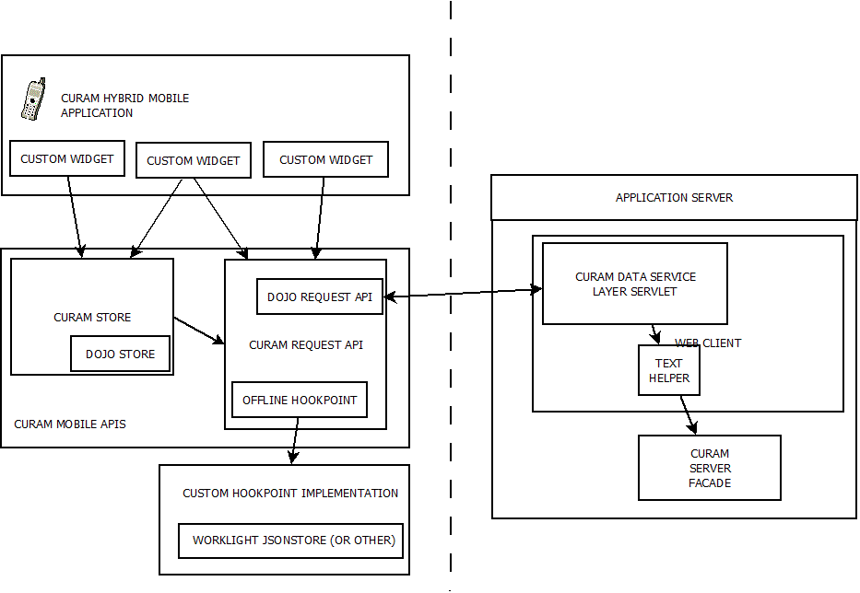
When using the request API, a configuration option (per request or instance of request) will be available to indicate if the result should be cached. Then, if there is no network connection and the cache has been configured, each request will check the cache for the content and if available will return it. The application developer should build into their API the error handling for if the content is not available in the cache, i.e. it has not been read before the network connection was lost.
Requests stored in the cache will be identified based on the service they are accessing and the set of parameters passed to the service.
As part of the detailed design for this feature, the following considerations will also be taken into account:
- The length of time content should remain in the cache
- The maximum size used by the cache, e.g. a First In First Out approach to content when a maximum size is reached
- The keys used for items added to the cache; this will have an impact on the efficiency of the search. Note: The efficiency of the search will be dependent on the storage mechanism used, so performance considerations here will be limited to the JSONStore example in the sample app.
- Default error handling and hookpoint for customization
  - Request Queuing
The Cúram mobile APIs will support the queuing of requests where a network connection is unavailable. This approach supports both sporadic network connectivity and offline enablement.
Where a network connection is unavailable, temporarily or for a longer period of time, the request will be queued in the same cache configured for caching of read results. When the network connection becomes available again, the requests will be retried in order of when they were received.
As part of the detailed design for this feature, the following considerations will also be taken into account:
- The number of times a request should be retried (configurable), or if it should wait permanently.
- The maximum number of requests to queue
- The ability to cancel requests
- The ability to identify multiple requests and control whether only one should remain in queue
- Error handling, including default behavior and hookpoints for when the maximum number of retries is reached
- Hookpoints for handling the response when eventually processed
Mobile applications using this feature need to be developed in a specific pattern to handle intermittent loss of connectivity. For example, any request to the server cannot be relied upon to return. The asynchronous nature of AJAX requests is well suited to handle this. For example, dojo uses the idea of a promise, which is basically a callback that is invoked when the request is processed. A loading symbol is regularly displayed on the portion of the screen that is waiting for a server response.
Examples of how to implement a mobile application in this asychronized approach will be included in the sample mobile application.
  - Worklight Caching Support
Worklight supports two data caching mechanisms:
- Encrypted Offline Cache (EOC) API
Based on the HTML5 local storage technology, with a limit on the amount of information that can be stored within HTML5 local storage (5 MB). Data encryption is achieved through the use of a user-provided password and a server-retrieved randomly generated token. See here for more information.
- Worklight JSONStore
JSONStore provides a persistent storage of JavaScript Object Notation (JSON) documents and is limited in size by the device space only. It provides different types of data encryption such as 256-bit Advanced Encryption Standard (AES) and PBKDF2. See here for more information.
Use of the JSONStore is recommended over the EOC API and examples of the usage of this will be included in the sample application.
  - Non Functional Requirements
    - Performance
Performance of the offline features for the Cúram mobile SDK is highly dependent on the caching mechanism used. Specifically, the ability to efficiently search the cache for content is key.
The mechanism to be used as part of the sample is the JSONStore and the documented guidance for ensuring content added to this is added and retrieved in an efficient manner will be followed. Beyond this, no performance investigation will be done in this area.
    - Security & Regulation
The majority of IBM Cúram customers are governments and have strict compliance and guidelines around encryption and data protection. For example the Federal Information Processing Standards (FIPS) or the Health Insurance Portability and Accountability Act of 1996 (HIPPA).
For offline support we are deferring the responsibility of the caching mechanism to the customer, however the JSONStore that will be used in the example can be FIPS compliant:
“Android and iOS devices both enable the use of FIPS 140-2 validated libraries for encryption and decryption of locally stored data. By default JSONStore utilizes non FIPS 140-2 validated libraries. As JSONStore uses an open source library called OpenSSL to encrypt data, the FIPS compliant version of this library can be used. This will ensure that JSONStore will operate in FIPS compliant mode.” (source)
- Pagination
  - Overview
The Cúram mobile SDK will provide basic support for mobile specific pagination scenarios that enable reduction of data sent to the mobile application.
Pagination, as currently implemented for the Cúram webclient, is browser specific pagination. This is achieved by returning all records to the browser, with only the initially displayed items contained in HTML and the rest of the content hidden in a script block. This allows the browser to ignore, i.e. not parse, the additional items and improve performance. When next is selected on the list, the next block of items are retrieved from the script block and displayed.
If any ordering is done on the columns in the list, the user is returned to the first page of the list with it reordered. This is done purely in JavaScript, with no additional calls to the server.
This solution is not suitable for a mobile device; the amount of data returned is too large given network/bandwidth considerations and the JavaScript processing is intensive where processors and battery power are a consideration.
The solution is to implement a web-tier cache of list content and support pagination using the new Cúram mobile APIs. The pagination support will not cater for re-ordering of items in the list. The main reason for this lack of support is that anecdotally reordering of lists is not a general mobile paradigm.
  - Pagination in Cúram Data Service Layer
Caveat: The solution for pagination has only been considered at a very high level and requires the full design to be developed further.
The Cúram mobile APIs support a Cúram store, which is an instance of Dojo’s store API. This APIs lends itself to supporting pagination by allowing options to be specified with requests to the store. For example, where pagination is enabled in the store, the first block of items is returned with an indication of how many items in total exist. The next request can include an index, which indicates the next block to return.
The developer must specifically handle pagination scenarios and build these into the widgets supported for the user interface.
The web-tier, i.e. the CDSL servlet, will be responsible for handling the caching and indexes. There are a number of options here, that need to be explored further, but include:
- Cache the content per session, i.e. the full list is cached as part of the user’s session data.
This means that the content lives for only as long as the session is active and it is easy to maintain state for a particular user. This is ideal where there is unlikely to be overlap between the data requests from different users.
- Cache the content as part of the P&S cache in the web-tier.
Using the P&S cache at the web-tier allows content to be cached and shared across users for the same request.
- Do not cache the content in the web-tier and contact the server for the full list on each request.
This has performance implications for the server, however there is already an SQL cache in place on the server that in theory ensures the database is not hit each time around. Note: In a clustered environment this is not a guarantee if the server facilitating the request is not the same each time round.
The design will need to consider in detail:
- The size of the content added to the cache and the memory implications of this for the server
- Is it possible to share content across users? Are requests likely to be similar?
- How long will content be cached for?
  - Associated with user session?
  - Implications for seeing updates if cached for too long.
  - Non Functional Requirements
    - Performance
Performance is the largest consideration with regard to pagination. The performance engineering team will be involved from the early stages of the design to ensure the correct caching mechanism and approach is taken.
- Appendix 1 – Documentation
This intention of this section is to outline the external documentation that will be available to customers of the Cúram Mobile SDK. The following is a guide, and not a comprehensive list of what will be provided:
- JavaScript Documentation detailing the APIs that can be used and their expected behaviour;
- A Working with the Cúram Mobile SDK Guide that will cover, but not limited to:
  - Installation of Worklight and the Cúram sample mobile application
  - How to add and modify content of the sample application
  - Features of the Cúram Data Service Layer
  - Details of working with the raw and formatted values returned from the Cúram Data Service Layer
  - How to implement pagination support
  - How to implement offline authentication
  - How to use the Cúram caching feature
  - Details on authentication integration between Worklight and WebSphere, based on Cúram default OOTB authentication
- References to public IBM documentation that provides guidance on developing mobile applications.
- Appendix 2 - Glossary
Term | Meaning
Apps | Mobile applications
Worklight Studio | An Eclipse plugin supporting the development of mobile applications
Worklight Marketplace  (aka Mobile First Marketplace) | A Eclipse based plugin framework for additional utilities to support creating mobile applications
Worklight Server | The Worklight production environment supporting enterprise features such as security, analytics and device provisioning
Mobile Center of Competency (MCoC) Core Framework | A Worklight component providing a standard best practice base for creating mobile applications
DOU | Document of Understanding

- Appendix 3 – Project Stakeholders
See the Mobile SDK Design Wiki for more information.

- Appendix 4 - Decisions and Alternatives
  - Two Mobile Development Approaches
There were two approaches that Cúram considered in implementing a Mobile Development strategy for our customers.
- Mobile UIM
- Mobile Access Point
These two options are described in detail below which was based on our investigations over a number of weeks early 2013. In our investigations we researched and prototyped the various configurations and options available to both approaches and documented them here.
  - Mobile UIM
    - Introduction
If the Cúram infrastructure were to implement Mobile UIM support, it would allow customers to develop mobile applications using the existing UIM infrastructure. The advantages of UIM as a format for mobile UI development are similar to those for standard Cúram UI development:
- They make it quick and simple for developers who may not be skilled in this type of development to create interfaces and they make it easy to access server facades.
- It also enables our existing and future customers to have their Cúram client developers also develop Mobile Cúram Apps; this is something that would really excite our customers.
- The world of mobile app development currently lacks standards and is moving quickly. Should a new mobile development technology come to exist Cúram will be able to migrate Cúram mobile apps to use it by simply changing the mobile UIM tooling.
- It allows Cúram a convenient place to put tooling in place to ensure in-house developers and customers adhere to good practices relating to security, performance, usability, accessibility, etc.
The disadvantages to this approach are:
- There may be a poor return on investment; Cúram will need to invest substantial effort and time into developing, testing, and maintaining this type of tooling.
- In addition, the set of features supported are potentially restrictive to the customer and may not give them the flexibility they require for developing mobile apps.
- A standard Cúram application involves a multitude of pages which must be maintained; but mobile applications will be much sparser, probably consisting of less than a dozen pages, each of which will contain only a few fields and controls. Therefore UIM may represent less of a time-saving for mobile development as the time required for analysis and UI design will greatly outweigh the time required to actually implementing the apps.
    - UIM Gap Analysis
In order to determine whether the existing Cúram UIM infrastructure could easily map to Mobile App development requirements, a gap analysis was performed. The gap analysis concentrated on two existing Cúram Mobile App Use Cases which have defined mobile App requirements. The two use cases can be found on the following links:
- Child Care mobile application
- Universal Access mobile application
The gap analysis found that there were specific Cúram Mobile App requirements that could not be easily mapped to the existing UIM infrastructure.
The Gap analysis documentation can be found at the following location:
- Child Care UIM Gap analysis.d​oc.
- UIM Gap fit UA use case.doc.
From the Gap analysis the following is a summary of the gaps identified in the existing Cúram UIM infrastructure.
- Adjustable UIM CLUSTER widths and heights of columns are not supported
- NATIVE MAPS cannot not be implemented in UIM
- Variations of FIELD LABEL layout is not possible in UIM
- UIM LISTS cannot handle a row with Hyperlinks and another row with text only
- UIM CLUSTERs do not support the display of Dynamic images
- UIM LISTs do not support LISTs filtered & divided by Categories and sub Categories i.e. tasks due, future tasks due etc…
- UIM LISTS do not integrate with native maps
- UIM cannot create an intelligent script flow of screens
- UIM EDITABLE LISTS do not support LISTs filtered and divided by Categories i.e. A,B,C, as Person name categories
- UIM EDITABLE LISTS do not support EXPANDABLE LISTS that are editable.
In conclusion the gap analysis has identified that there is a significant gap in what is currently available in the UIM infrastructure and what has been identified in the existing Cúram Mobile app use cases. These gap requirements would necessitate a substantial additional investment to support UIM features applicable to mobile application development.
    - UIM Infrastructure
An infrastructure to support converting UIM to some form of mobile app can take a number of forms. The general approach is to generate the mobile app “content” from the UIM; this is the same approach for the existing UIM.
There are two technical approaches that were considered for what content could be generated and where it would reside. The main difference between the two approaches is whether the “content” is embedded within the mobile app or dynamically retrieved from the server.
- Approach 1: A JavaScript mobile application that does not contain any content. This shell application must contact the server for all content, i.e. navigation structure, page structure and data;
- Approach 2: A mobile application that contains JavaScript and generated HTML pages for each UIM. This application must contact the server for data only.
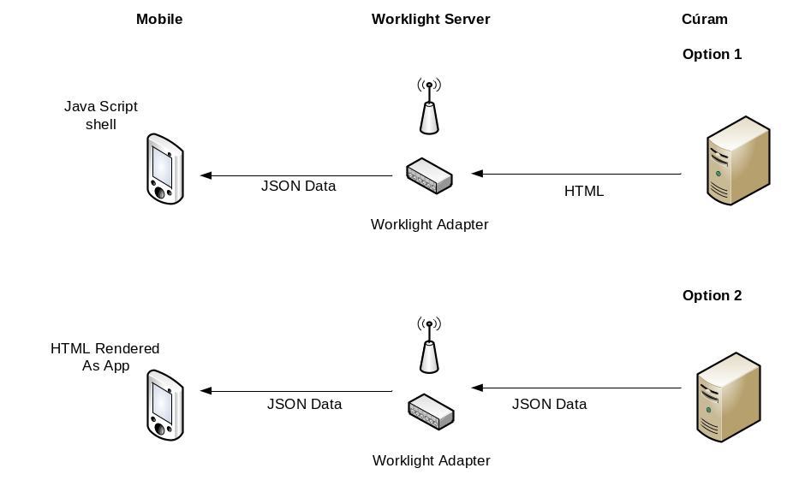
    - Approach 1: The JavaScript Shell App
The JavaScript Shell App approach is where all the main content is retrieved from the Cúram web-tier. The mobile application is purely JavaScript infrastructure for displaying or “playing” this content.
The JavaScript infrastructure retrieves the initial navigation configuration from the Cúram web-tier (JSON) and uses this to build the navigation controls for the application. Any navigation controls, when selected, then replace one (or more) content areas dynamically with HTML content also retrieved from the Cúram web-tier. HTML content maps one to one with UIM pages.
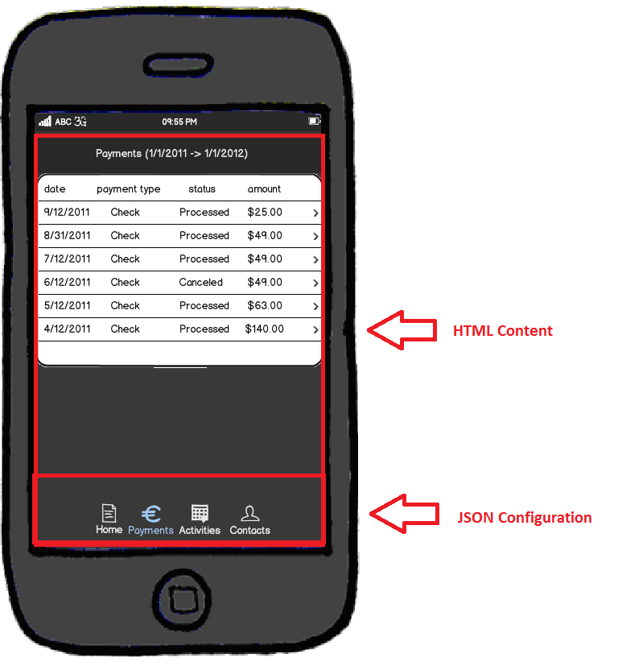
The HTML content retrieved contains the structure of the page/content, as well as the data embedded in this structure. To optimize and reduce the payload of each request, the full HTML content will be deferred to JavaScript widgets, which are part of the mobile application.
For example, the generated HTML (from UIM) for a list in Cúram follows a structure similar to:
<table id="sortable_N2439E">
<colgroup>
<col width="50%" class="field">
<col width="50%" class="field">
</colgroup>
<thead>
<tr>
<th id="N243D3" class="field">
<span><a href="#">Person<span class="hidden"></span></a></span>
</th>
<th id="N243E1" class="field">
<span><a href="#">Address<span class="hidden"> </span></a></span>
</th>
</tr>
</thead>
<tbody>
<td class="field">
<div class="context-panel-wrapper">
<div class="personsearchname">
<a class="ac " href="Person_resolveHomePagePage.do">Granpa Smith </a>
</div>
</div>
</td>
</tbody>
</table>
In reality, the above is more verbose than is worth displaying. In a mobile app, the HTML generated and returned to be parsed by JavaScript would be simplified to something similar to:
<ul data-dojo-type="dojox.mobile.RoundRectList">
<li data-dojo-type="dojox.mobile.ListItem">Data</li>
<li data-dojo-type="dojox.mobile.ListItem">Data2</li>
</ul>

The HTML becomes basic instructions to define which JavaScript widgets to use and the data to use with them. A balance is required in this approach between the size of the HTML content returned (network limitations) and the amount of JavaScript processing required by the app (battery life/performance). For more details consult the Non-Functional Requirements section.
Advantages
- This approach fits with the existing infrastructure (e.g. renderers).
- Approach is highly configurable. For example, changes to the UIM/configuration can be seen immediately in the mobile app, without the need for a rebuild of the mobile app binaries and delivery of a new application.
Disadvantages
- Larger payload and increased communication with Cúram web-tier.
- Offline support requires content and pages to be pre-loaded.
- Complex offline scenarios potentially more difficult to support.
Cúram Infrastructure Support
The following JDE infrastructure changes would be required to support this approach:
- Extend the existing renderer infrastructure to support different renderers depending on context, e.g. mobile vs. external vs. internal.
- Introduce support for mobile app configuration data, including development and runtime administration.
- Implement Dojo mobile JavaScript “player” infrastructure.
- Develop new Renderer and JavaScript widgets for supported features, e.g. clusters, fields, lists, etc.
This list is not intended to be comprehensive and does not include the development and build support required for working with Worklight and building the mobile applications. This is common to both approaches.
    - Approach 2: HTML Generated App
The HTML Generated App approach is where the majority of the configuration and structure of the mobile application are generated JavaScript/HTML, built into the mobile application. Communication with the Cúram web-tier is to retrieve data to be embedded in specific generated pages.
For each UIM page, a static HTML page will be generated to include in the mobile app. The static HTML page will outline the structure of the page and details of what data to retrieve from the web-tier.
The JavaScript infrastructure will use generated configuration data to “play” the mobile application, loading the static HTML pages as they are navigated to.
Advantages
- Network payload reduced to only JSON data, i.e. Structs of data.
- Potential performance gain due to local resources.
- Potentially easier infrastructure to cater for complex offline scenarios.
Disadvantages
- New infrastructure for generation of mobile HTML content, which is not in keeping with move to dynamic content.
- Not configurable, as it requires a rebuild of Cúram and the mobile application with each change.
Cúram Infrastructure Support
- The following JDE infrastructure changes would be required to support this approach:
- A completely new generation mechanism for converting UIM to mobile HTML will need to be designed and developed.
- Implement Dojo mobile JavaScript infrastructure.
- Develop JavaScript widgets for supported features.
This list is not intended to be comprehensive and does not include the development and build support required for working with Worklight and building the mobile applications. This is common to both approaches.
    - Development Environment
Where Cúram are generating the HTML and JavaScript for the mobile application, the aim of the development environment is to allow the creation and testing of mobile applications as simple as possible for our customers. Ideally they should not have to worry about any part of the mobile application and it should “just work” after a build for them.
The Worklight Studio Development section above outlined the steps required to develop a mobile app using Worklight. Developing using Worklight requires significant setup and an understanding of Worklight, JavaScript, Dojo and HTML. With this approach, Cúram aims to abstract as much of this as possible, using automation and scripting. Ideally the customer should only use the simulator aspect of Worklight to test out their mobile app.
Worklight Studio does not currently provide any support for automation or scripting. This results in some difficulty for Cúram to abstract the above outlined process and provide a generated version of the mobile application.
Worklight Server does provide support for automation, specifically for building a Worklight project (including adapters) and deploying the application to a Worklight Server. The “Build All and Deploy” step of Worklight studio is creating a Worklight application (.wlapp) and deploying it to an internal webserver within Eclipse. (The webserver is based off Jetty.) Worklight Server provides a number of ant tasks to perform essentially the same tasks, pointing at the Eclipse Worklight project for the source.
  - Mobile Access Point
The following is the original outline of the Mobile Access Point architecture. This is now called the Cúram Data Service Layer and is detailed in the main sections of this document.
    - Introduction
A Mobile Access Point would allow customers to expose a set of server interfaces/facades to be used by a mobile app, leaving the development of the mobile app to the customer.
The interfaces exposed should be optimized for mobile usage. Optimizing the output of the interface includes ensuring the data is reduced only to what is necessary for the display. Cúram may potentially provide optimized OOTB APIs that are suitable for mobile usage, but with this approach it will be the responsibility of the customer to implement/identify APIs that can safely be used by a mobile app.
The advantage to this approach is the level of flexibility that it gives to the customer when creating mobile applications. However, unfortunately it requires a skill set that customers may not have at present and moves the majority of the non-functional aspects of mobile applications to the customer’s responsibility.
To mitigate the work required by the customer, Cúram will need to provide best practice documentation and sample mobile applications. In addition, infrastructure API support will be required to aid the customer in writing mobile apps that use Cúram proprietary data such as code tables.
This approach potentially represents less of an investment for Cúram, but significant infrastructure is still required to aid the customer.
    - Access Point Infrastructure
The diagram below shows some of the existing access points for accessing data and services within Cúram:
- Browser clients generally communicate over HTTP using UIMs. In addition there are some servlets providing specific services, e.g. File Download, IEG Editor Support, etc.
- Batch programs communicate using RMI by directly invoking our general purpose bean (EJB Method). This mechanism is not supported for customer usage.
Custom clients can communicate with the server using web services, over HTTP, which have been modelled and developed by the customer.
Browser/Client
Web-tier
Server
EJBMethod Bean
Webservice Facade
Text Helper
WebService
Browser
Batch
Custom
UIM
Resolve
RMI
Servlet
Providing an access point for mobile applications means exposing a “service” that allows for invocations of server interfaces (aka facades). For security reasons, such a service should not expose all existing facades for use by mobile, and should define in some way a limited set of “mobile targeted” facades.
For example, exposing the general Person.read façade is not a good idea as this API would allow anyone with access to Cúram to read the data for any user once they know their SSN. Note, this is a contrived example, but illustrates the point! Ideally all “mobile targeted” facades should be carefully picked and should provide “data based” security which ensures the current user has access only to information relevant to them.
Limiting the set of APIs means some “configuration” needs to be defined, identifying the facades that can be used and potentially narrowing what data will be returned by them.
    - Access Point Options
There are three potential implementations for such a service:
- A servlet that opens up access to a limited set of façade server interfaces
- A JSON data provider UIM
- Web Services
Each of these approaches is outlined in more detail below, but essentially they provide the same thing. A HTML service that allows for the invocation of a specified server interface/façade, as outlined in the diagram below.
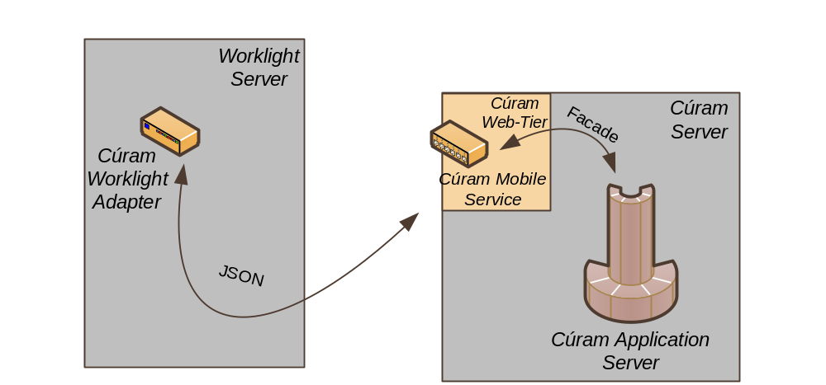
    - Servlet
A version of this approach was used for the original sample mobile applications. The servlet in that case essentially provided a HTTP access point to call any server interface in the application.
A version of this servlet would be extended to allow it to be configured to limit the server interfaces accessible. For example, the configuration data for such a service may look like:
<mobile-services>
<service name=”Client”>
<function name=”read”>
<server-interface class=”ParticipantExt” operation=”read”>
<data-scope> <!—- Optional to reduce ouput -->
<field name=”fullname” struct-name=”fullname”/>
<field name=”address” struct-name=”address”/>
<data-scope>
</server-interface>
</function>
<function>…</function>
</service>
</mobile-services>
The configuration data may potentially be dynamic information on the server, allowing existing APIs to be exposed for a new mobile application on an existing server.
Such a service would be accessed using a URL similar to:
https://server:port/CuramMobile/Client?function=read&param1=abc
The return would be JSON data similar to:
{“fullname”:”James Smith”, “address”:”ABC Street”}
The servlet service provided here can take advantage of the existing web-client data formatting support, potentially returning both the raw and localized/formatted data.
    - UIM Data Provider
An alternative to the servlet mechanism was implemented in Cúram 6.0.4 using UIM pages, for internal use only. A UIM page can be identified as a “data provider”, specifying the SERVER_INTERFACE whose data will be returned. When this UIM page is called, via HTTP, the infrastructure converts the content returned by the SERVER_INTERFACE into JSON data and returns it to the requesting browser.
For example such a UIM page would look like:
<?xml version="1.0" encoding="UTF-8"?>
<PAGE PAGE_ID="DataServiceLongList" COMPONENT_STYLE="DATASERVICE">
<SERVER_INTERFACE NAME="LISTDISPLAY" PHASE="DISPLAY"
CLASS="ListTesting" OPERATION="getLongList" />
</PAGE>
The UIM pages essentially each define a mobile service, as is defined in the servlet configuration data. However, this approach is a development approach, requiring UIMs to be created and compiled.
For mainly this reason, this approach is not being recommended.
    - Web Service
Cúram currently supports the creation of web services, based on existing facades/server interfaces. Customers can mark a modelled interface to be web service and Cúram will generate the necessary collateral to support this interface as a web service.
Cúram supports both SOAP and Document Oriented web services, in addition to including WS-Security support.
At present, customers could use this mechanism as is to expose existing server interfaces, however this requires modelling and development on their part. An alternative is for Cúram to provide an OOTB generic web-service which provides access to a white-list of facades. As in the servlet approach above this white-list would be “configuration” of the web service.
One of the main differences between exposing a web service versus implementing a servlet in the web-tier is related to data formatting. The servlet (and UIM) approach can easily leverage the existing client infrastructure to return localized and formatted data. A web service can only return raw data. The main reason for this is that web services are implemented as standalone infrastructure, and not linked with the current CDEJ client infrastructure.
For example, dates are returned from the server to the web-tier in an ISO standard format and the client infrastructure then converts these into a human readable date formats based on configurable settings. In addition, code table values are converted into locale specific descriptions and informational and error messages are localized according to the user’s locale.
WS-Security support is one of the nice features provided by web services. However, the authentication aspects of Axis2/Rampart are not supported by Cúram. Given this, the integrity (signature), confidentiality (encryption/decryption) and non-repudiation (timestamp) features do not add significant enough value that makes it worth using web services over a custom HTML service that can leverage client formatting and error handling features.
Preferred Approach
Of the three approaches the Servlet approach is recommended because of the potential reuse of the existing client infrastructure including formatted and localised data.
    - Data Contract
Via the mobile access point the customer will be using data directly returned from Cúram in their mobile app JavaScript, as a result a formal and documented contract on the format of the data will be required.
It is worth re-iterating that with this approach the mobile application developer will need to be aware of infrastructure data formats, such as code tables and frequency patterns, and how to handle these. For example, in the web-client, when a code table field is being used both the code table value and its localized description are sent to the browser.
In UIM, the developer does not need to worry about this mapping as the infrastructure caters for this under the hood. With a mobile application, the developer will need to know about this mapping and ensure that the correct content (e.g. code value) is returned to the server when submitting changes.
The base domains supported by the client infrastructure include the following:
- SVR_BLOB – A binary piece of data. This is always supplied in the raw format and further infrastructure services are required around this.
- SVR_BOOLEAN – Accepted values are true, yes and on or false, no and off.
- SVR_CHAR – A single character.
- SVR_DATE – The raw format is yyyyMMdd, with zero date as empty string. The formatted value depends on the ApplicationConfiguration.properties date settings.
- SVR_DATETIME – The raw format is yyyyMMddTHHmmss, with zero date as empty string. The formatted value depends on the ApplicationConfiguration.properties date settings.
- SVR_DOUBLE – The raw format contains dot for decimal point and commas separated hundreds and thousands. The formatted value contains the correct separators for the users locale.
- SVR_FLOAT – As for SVR_DOUBLE, but with absolute magnitude of min and max values as per java.lang.Float.
- SVR_INT8, SVR_INT16, SVR_INT32, SVR_INT64 – The raw format may contain commas for separators, and the formatted value will contain the locale specific separators. The absolute min and max values are as per java.lang.Byte, java.lang.Short, java.lang.Integer and java.lang.Long respectively.
- SVR_STRING – A basic string, potentially with a maximum size.
- SVR_UNBOUNDED_STRING – An unbounded string.
- CODETABLE_CODE – A string representing a code table code for a specific code table.
- CURAM_TIME – The raw value conforms to THHmmss, with the formatted value using the date/time setting in ApplicationConfiguration.properties.
- ADDRESS_DATA – The raw value is TBD, with the formatted value matching the associated address format. For example, UK addresses vs US addresses.
- FREQUENCY_PATTERN – The raw format is a nine character sequence representing the various supported patterns. The formatted value is the localized text for this pattern.
- LOCALIZED_MESSAGE – The raw format takes the form CATALOG:MESSAGE:(arg1|arg2), with the formatted being the localized text, with parameters substituted.
- SEC_PASSWORD – TBD
- INTERNAL_ID – Maps to SVR_INT_64 and represents a Cúram generated unique ID.
The above list is not a comprehensive list of all supported domains. There are domains defined for specific widgets, e.g. EVIDENCE_XML_COMPARE and PIE_CHART_XML, which will not be supported for mobile applications. The above is the intended to be the initial supported list.
    - Infrastructure Services
The Cúram CDEJ client infrastructure abstracts a lot of infrastructure from developers, including details of the above raw versus formatted values. To aid customers when manually developing mobile applications a number of additional infrastructure services would need to be developed. The following is the list of suggested services. These services will ideally be implemented/wrapped in a JavaScript API that the customer can include in their mobile application, i.e. cdej-mobile.js.
Note: These are based on the existing infrastructure support, but all may not be required by mobile apps.
- Code Table Support
API to retrieve the full definition for a particular code table and functions to translate code values to the descriptions.
- Domain Support
API to retrieve Domain information.
- Field Level Security
A service to determine if a particular field is secured, based on the user. This may be done within the mobile access point service and needs consideration. For example, we can check if the field is secured before the data is returned, instead of allow the mobile application to implement this.
- User preferences Access
API to access a specific user preferences and the list of all user preferences.
- Global Cúram Configuration Access
API to access to both the client configuration settings and the full application properties (.prx). Client configuration settings include Date/Time settings, address formats, default locale, etc. Not all of these would be applicable to a mobile and only those necessary should be exposed.
- Binary Data Access
API to support accessing binary data, such as images, from the server. This API needs to consider, at a minimum, both accessing images from the Resource Store and general access to tables that are using the SVR_BLOB domain.
    - Pagination Support
Currently Cúram supports pagination at the browser level only. The full content list is returned to the browser, but only a portion of it will be displayed initially. JavaScript handles display the remaining “hidden” content when requested. This is not optimal when developing a mobile app, as the amount of data returned is a primary concern.
Traditionally pagination has been a complex issue to resolve with infrastructure support, but for mobile apps at a minimum a recommended approach for customers would be required. It would be preferable to include infrastructure support for this, but will be a second phase consideration.
    - Error Handling
There are two general approaches to error handling for the mobile access point:
- HTTP 500
HTTP 500 indicates an internal server error occurred and includes the error message in the HTTP body. The Worklight Adapter handles this by including the error information in the JSON returned to the mobile application.
- HTTP 200
HTTP 200 indicates that the request was successful. However, in the case of an error the JSON returned would include details of the error.
- This approach bypasses how the Worklight Adapter handles errors, in that the response will always be a successful on.
In both cases, the mobile application developer is responsible for how it handles the error response and will need to know what to expect. The advantage of the HTTP 200 approach is that it would allow us to return multiple error message, as in the case of validations, to the client.
HTTP 200 is the preferred approach at present, but further investigation will be required when the detailed design is considered.
    - Packaging of the Access Point
Deployment/packaging of the mobile access point plays an important role in the flexibility of a production level configuration. The recommendation is to support the ability to deploy the mobile access point both as part of a standard Cúram EAR and as a standalone EAR file.
In addition, support for multiple versions of the access point should be provided. This means that the access point configuration should be related to the web-client context that it will be deployed as part of.
For example, two mobile applications have been implemented, one for usage internally within the organisation and one accessible by the general public. Each mobile application has a different set of interfaces and exposing the interfaces used by the internal mobile app is not recommended by the customer. In this scenario, the general public mobile app will have its own access point deployed as a separate EAR and run outside the firewall. The internal mobile app will use the access point deployed within the Cúram EAR file.
The standalone mobile access point EAR file will include only the access point and no other files. Configuration of the exposed server interfaces will still be possible via the administration screens within the internal Cúram application.

